- Select the Session Send Vendor Document for Technical clearance Pre Order.
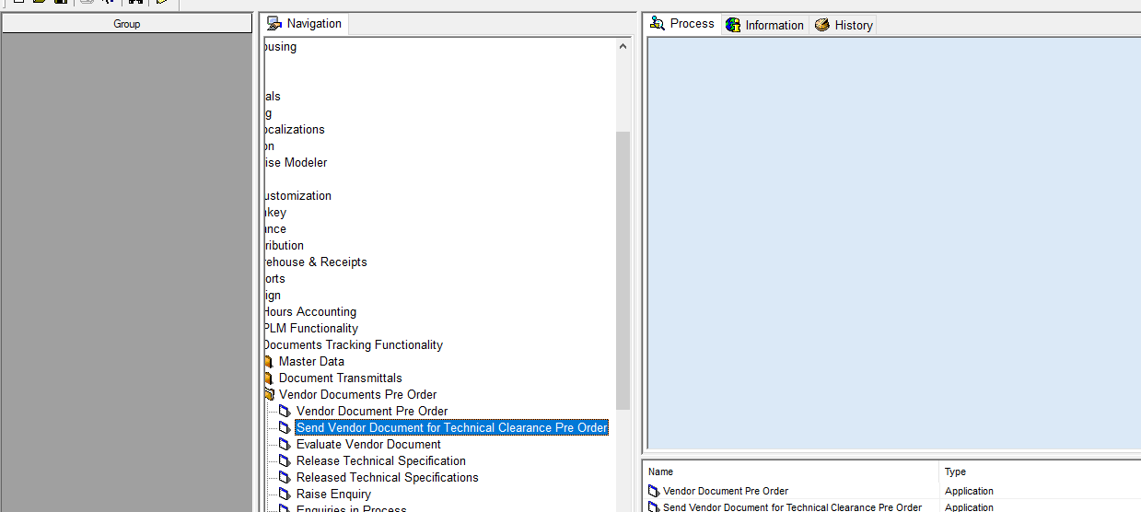
Click this Session

- Check the IDMS Receipt No if the status is Submitted then Click on the Disciplines to whom you want to forward the offer for technical Vetting. If the status is Under Evaluation just Exit the session.
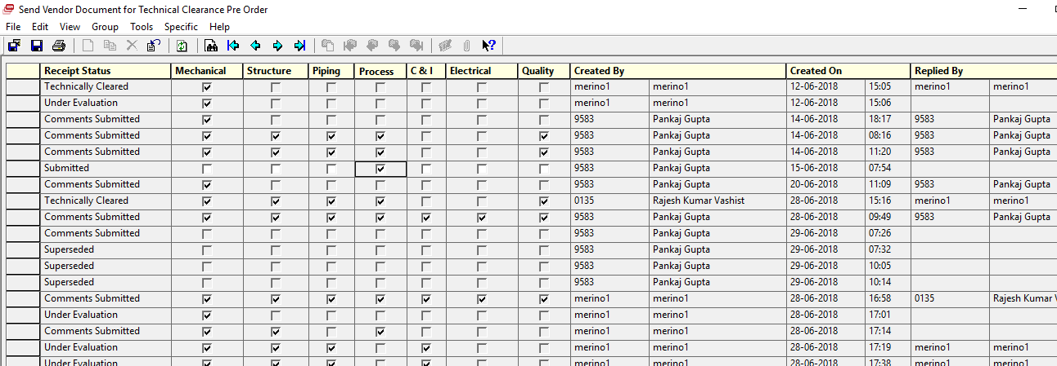
Submitted
Select Process

- Highlight the IDMS Receipt Line the go to specific and select Process.
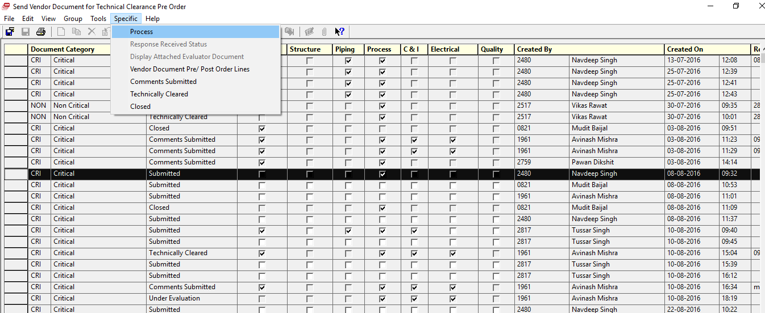
Select the Receipt line
Process

- The Receipt Status will change to Under Evaluation. Exit this Session.
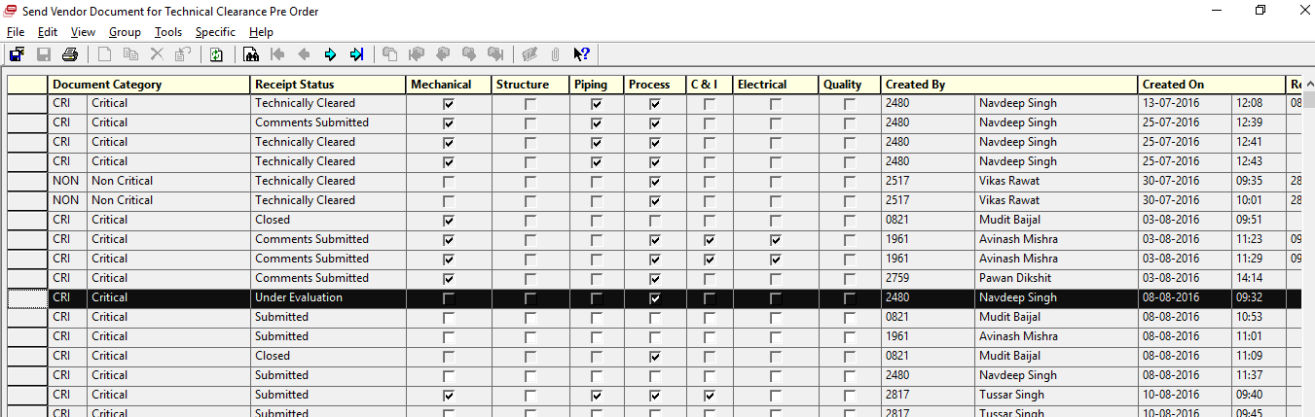
Under Evaluation

- Engineering to Evaluate using existing session Evaluate Vendor Document.
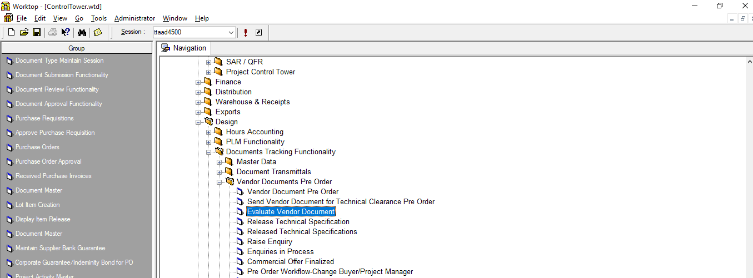
Evaluate Vendor Document

